Use Cases and Architectural Report

Use Cases

Manager
Managers can use the “Restaurant Management Application” to create floors for their business. Once the floor is created, they can choose to resize the floor or swap between floors. Managers can set up floor plans similar to the real arrangement by adding or replacing tables. Once the floor plan is configured, they can perform different actions on the tables.

Waiter
Waiters can use the “Restaurant Management Application” to manage order and reservations by being able to create and edit reservations and adding orders. Once a reservation or a order is made, waiters can easily and effortlessly visualize information about the reserved tables and tables with pending orders on the floor. Moreover, waiters can get information about the entire menu anytime.

Client
Clients can scan a QR code to view the menu and his current order.

Use Case Model

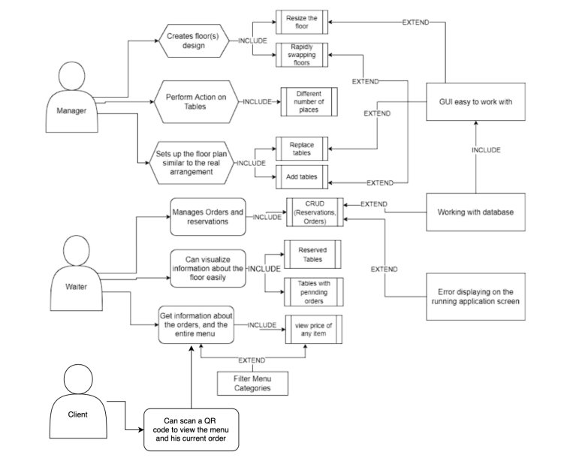

Main quality attributes of the application

Reliability
Our application is reliable because of its compatibility and portability. It is highly compatible
because it is based on the Flutter framework, which supports a variety of different platforms and operating systems. It is also portable because the users only need to download the application itself in order to be able to start using it. Because of the way it was designed, availability is also not an issue, as the application can even run without an internet connection, because it runs locally.

Usability and reusability
Our application is easy to use for the customer because of its intuitive UI and design, especially because of the graphical floor presentation of the restaurants' tables. It is also reusable because of how easy it is to create different table configurations, on different floors of the restaurant.

Effect on stakeholders
Our application enables our stakeholders (Boema House, The Junction Grill, Mike's Pub) to increase efficiency and productivity in running their restaurant businesses by digitalizing their logistical management and servicing processes because of the application's focus on usability, which also results in higher customer satisfaction.
The application's reliability is also important for our investor, The Junction Grill, because it helps them further market the application to more restaurant business, expanding its customer lineup and increasing their ROI(return on investment).

Tactics used to satisfy QAs
In order to have a more efficient QA process, before any changes are reviewed by the QA team, a GitHub Actions pipeline is run which performs regression tests which validate that the core actions of the application are still fully functional and behave as expected. Our development team will also perform Negative Testing and User Acceptance Tests on the application during development and the last sprint will be based on TDD (Test Driven Development).

Architectural Design Pattern used in our application
Our application is designed and implemented based on a Layered architectural pattern. Data is transferred between the three different layers of the application:
Presentation
Service and business logic Data access
This is a conscious choice which our development team made during the Discovery phase which was made because this pattern increases code readability, scalability and modifiability.

Diagram that describes the Application Structure Org

